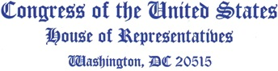

December 14, 2022

The Honorable Nancy Pelosi
Speaker of the House
U.S. House of Representatives
H-232, The U.S. Capitol
Washington, D.C. 20515

The Honorable Kevin McCarthy
Republican Leader
U.S. House of Representatives
H-204, The U.S. Capitol
Washington, D.C. 20515

Dear Speaker Pelosi and Leader McCarthy,
We write to request your support for policies to address impending Medicare payment cuts in legislation moving through the U.S. House of Representatives before the end of the year. We offer our assistance in finding a solution in order to ensure continued and robust access to care for American seniors.
Health care providers are facing unprecedented burnout and turnover emerging from the COVID-19 pandemic, a major concern of the U.S. Surgeon General, Dr. Vivek Murthy. We are concerned that severe, impending reductions to Medicare payments will result in hiring freezes, elimination of services provided to seniors, and decreased patient access to health care services, especially following a year of record high inflation.
We are particularly concerned about the impact of Medicare cuts in rural and underserved communities. With an ongoing health care workforce shortage, American communities cannot afford to experience practice closures. Uncertain payment rates will only lead to physicians closing their doors and enhance the existing barriers to care these patients already face, exacerbating poorer quality of life for seniors.
We appreciate the work Congress has historically done to alleviate payment cuts for providers and recognize that Congress must again act before the end of the year to address looming cuts.
We look forward to working with you on both responsible short-term payment solutions and long-term improvements. Attention to overarching payment reforms will be essential in fulfilling Medicare’s promise to current seniors and future generations. Policies that address physician payment stability in the immediate future and beyond will be critical to the continued success of the Medicare program.
Thank you for your consideration and for your continued leadership.

Sincerely,
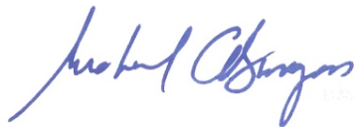
Michael C. Burgess, M.D.
Member of Congress


Andy Harris, M.D.
Member of Congress


Earl L. “Buddy” Carter
Member of Congress


Jefferson Van Drew, D.M.D.
Member of Congress

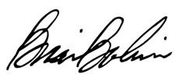
Brian Babin, D.D.S.
Member of Congress

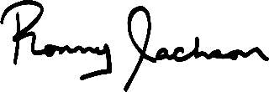
Ronny L. Jackson, M.D.
Member of Congress

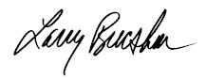
Larry Bucshon, M.D.
Member of Congress

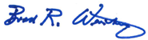
Brad R. Wenstrup, DPM
Member of Congress

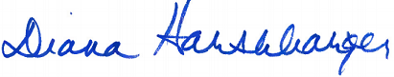
Diana Harshbarger
Member of Congress

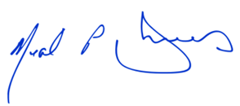
Neal P. Dunn, M.D.
Member of Congress

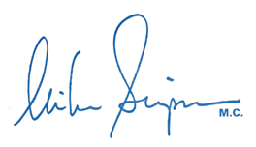
Mike Simpson
Member of Congress

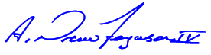
A. Drew Ferguson IV
Member of Congress

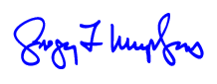
Gregory F. Murphy, M.D.
Member of Congress

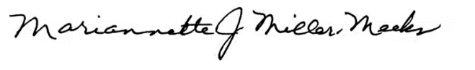
Mariannette J. Miller-Meeks, M.D.
Member of Congress

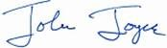
John Joyce, M.D.
Member of Congress

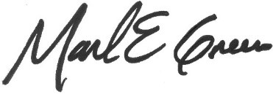
Mark E. Green, M.D.
Member of Congress

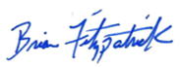
Brian Fitzpatrick
Member of Congress

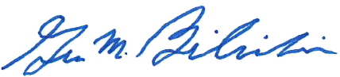
Gus M. Bilirakis
Member of Congress

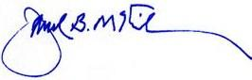
David McKinley
Member of Congress


Clay Higgins
Member of Congress

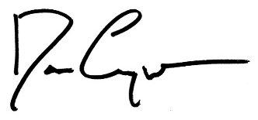
Dan Crenshaw
Member of Congress

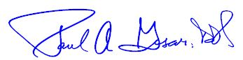
Paul A. Gosar, D.D.S.
Member of Congress

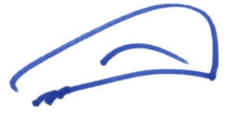
Scott DesJarlais, M.D.
Member of Congress


Stephanie Bice
Member of Congress

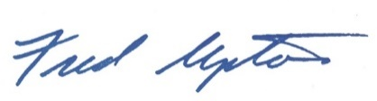
Fred Upton
Member of Congress

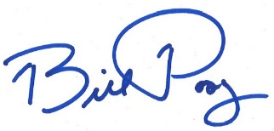
Bill Posey
Member of Congress

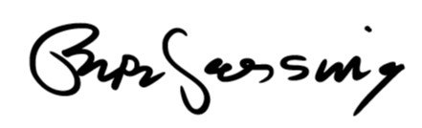
Pete Sessions
Member of Congress

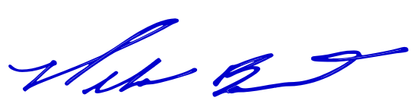
Mike Bost
Member of Congress

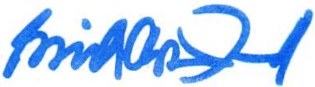
Eric A. “Rick” Crawford
Member of Congress


Jamie Herrera Beutler
Member of Congress


Randy Feenstra
Member of Congress

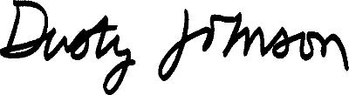
Dusty Johnson
Member of Congress

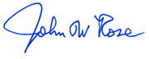
John Rose
Member of Congress

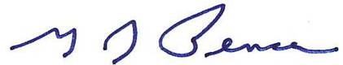
Greg Pence
Member of Congress

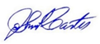
John R. Carter
Member of Congress

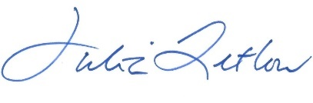
Julia Letlow
Member of Congress

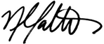
Nicole Malliotakis
Member of Congress

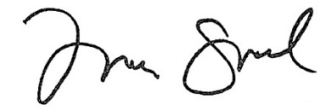
Michelle Steel
Member of Congress


Jack Bergman
Member of Congress

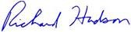
Richard Hudson
Member of Congress

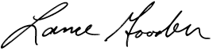
Lance Gooden
Member of Congress
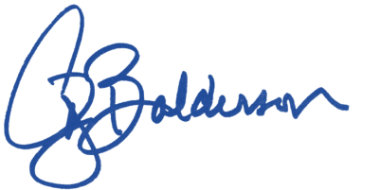
Troy Balderson
Member of Congress

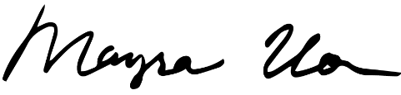
Mayra Flores
Member of Congress

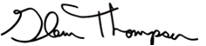
Glenn “GT” Thompson
Member of Congress

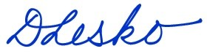
Debbie Lesko
Member of Congress

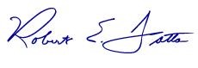
Bob Latta
Member of Congress

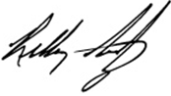
Kelly Armstrong
Member of Congress

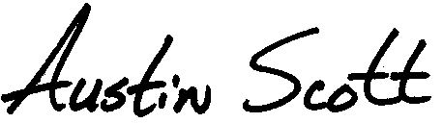
Austin Scott
Member of Congress

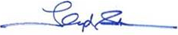
Lloyd Smucker
Member of Congress

Michael Guest
Member of Congress

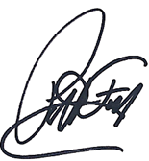
Pat Fallon
Member of Congress

David G. Valadao
Member of Congress

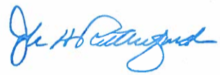
John H. Rutherford
Member of Congress

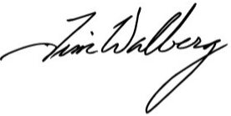
Tim Walberg
Member of Congress

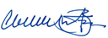
Cliff Bentz
Member of Congress


Tim Burchett
Member of Congress


Chuck Fleischmann
Member of Congress

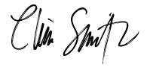
Chris Smith
Member of Congress

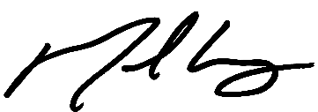
Mike Carey
Member of Congress

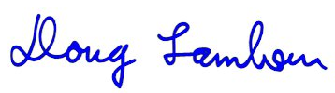
Doug Lamborn
Member of Congress
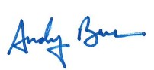
Andy Barr
Member of Congress


Young Kim
Member of Congress

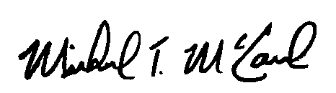
Michael McCaul
Member of Congress

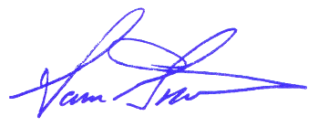
Sam Graves
Member of Congress
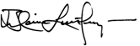
Blaine Luetkemeyer
Member of Congress

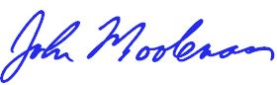
John R. Moolenaar
Member of Congress


David Kustoff
Member of Congress

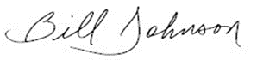
Bill Johnson
Member of Congress

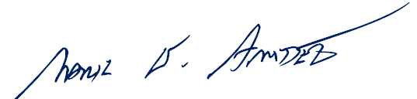
Mark Amodei
Member of Congress


Kat Cammack
Member of Congress


Guy Reschenthaler
Member of Congress

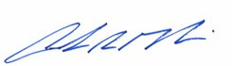
Andrew R. Garbarino
Member of Congress

James Comer
Member of Congress


Tom Emmer
Member of Congress

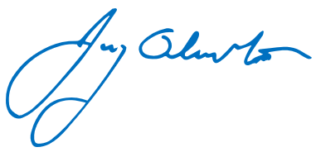
Jay Obernolte
Member of Congress

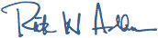
Rick W. Allen
Member of Congress

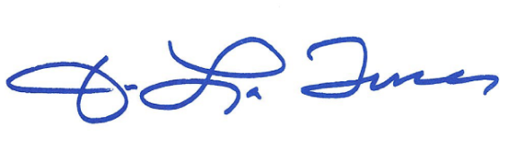
Jake LaTurner
Member of Congress

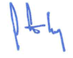
Trent Kelly
Member of Congress

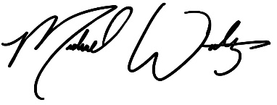
Michael Waltz
Member of Congress

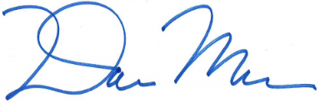
Dan Meuser
Member of Congress


Ron Estes
Member of Congress

Carol D. Miller
Member of Congress

